To begin searching for equipment visit: https://www.ohioinnovationexchange.org/
To search for a specific type of equipment use the search box at the top of the page.
- Use the drop-down menu labeled “Select a Database” to choose Equipment.
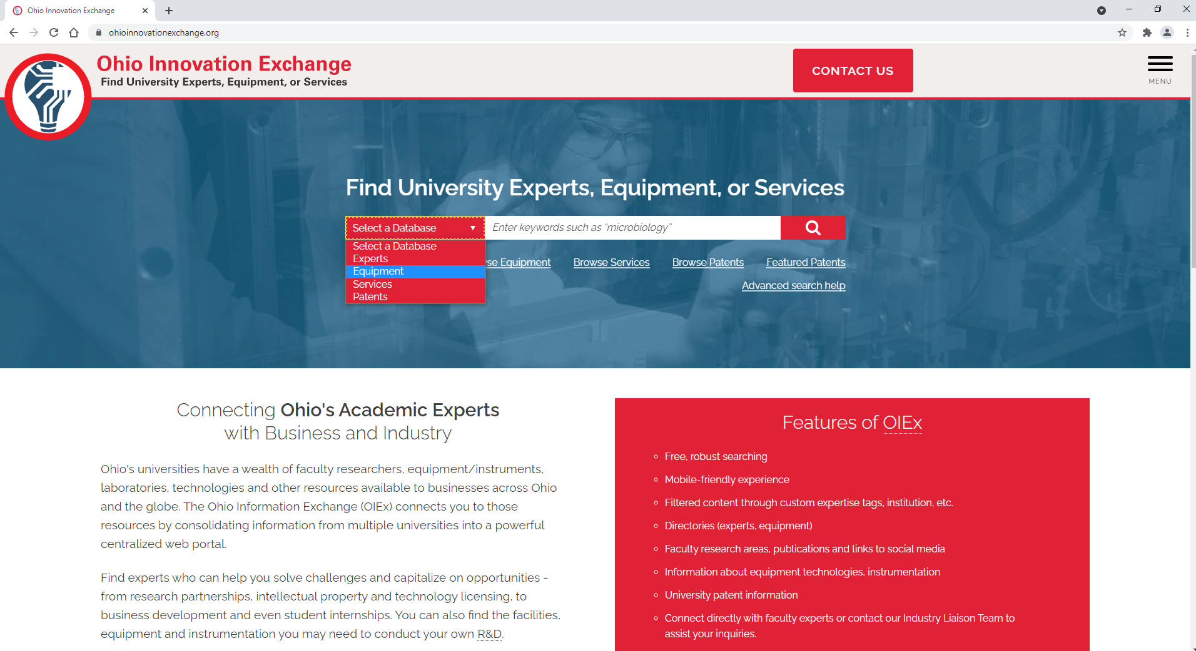
- In the text field, type the item you are looking for.
  - You can search broad categories or specific brands and models.
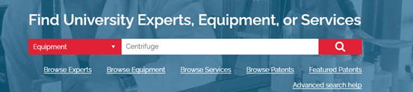
- Click the magnifying glass icon to begin your search, or press Enter on your keyboard.

- Your results screen will have 2 major sections

  - Search Results
    - See the number of results your search returned. Note that the default display is 20 results per page.
    - View the records for each result.
      - For additional details, click the title of the result you are interested in.
      - Use the URL field on the record’s page to link to the owning institution and find contact information. *Note*: There may be more than one URL in this field. If so, copy and paste the URLs individually rather than relying on the hyperlink.

  - Search Parameters
    - Narrow your search results by selecting specific fields that match your needs.
    - Fields include:
      - Keyword – the original search term you entered can be changed here to broaden on narrow the scope.
      - Equipment Types – select only instruments, or software for example.
      - Research Organizations – limit the results to institutions that are close to you for example.
      - Items per page – adjust the number of records you see on each page.
    - Click “Submit” to apply your filters to the search.

To browse available equipment, click the “Browse Equipment” link below the search bar.

- Your results screen will have 2 major sections
  - Search Results
    - See the number of results your search returned.
      - Note that the default display is 20 results per page.
      - You can jump to a particular range of records by using the drop-down menu beside “Go to records” and clicking “Go”.
    - View the records for each result.
      - For additional details, click the title of the result you are interested in.
      - Use the URL field on the record’s page to link to the owning institution and find contact information. *Note*: There may be more than one URL in this field. If so, copy and paste the URLs individually rather than relying on the hyperlink.
  - Search Parameters
    - Narrow your search results by selecting specific fields that match your needs.
    - Fields include:
      - Keyword – Enter a term here to narrow your results significantly.
      - Equipment Types – select only instruments, or software for example.
      - Research Organizations – limit the results to institutions that are close to you for example.
      - Items per page – adjust the number of records you see on each page.
    - Click “Submit” to apply your filters to the search.

