How to Locate Patents for Commercialization:
1. Choose Patents from “Select a Database” dropdown menu
2. Enter a keyword (could be a topic, organization, etc.) in patent database search field
3. Click search button
Patent Results can be limited by various filters (located in left and right columns) including:
- Publication Year
- Assignee
- Assignee Location
- Field of Research
- Patent Category
- Funder
- Featured Patents
Patent Results can be sorted by:
- Relevance
- Filed Date
- Patent Citations
Or grouped by patent family by checking off that box
Patent numbers, abstracts, references, families, and legal events are shown. The full text of patents
are not available in this database.
-Patents may also be browsed by clicking on the “Browse Patents” link under the search box
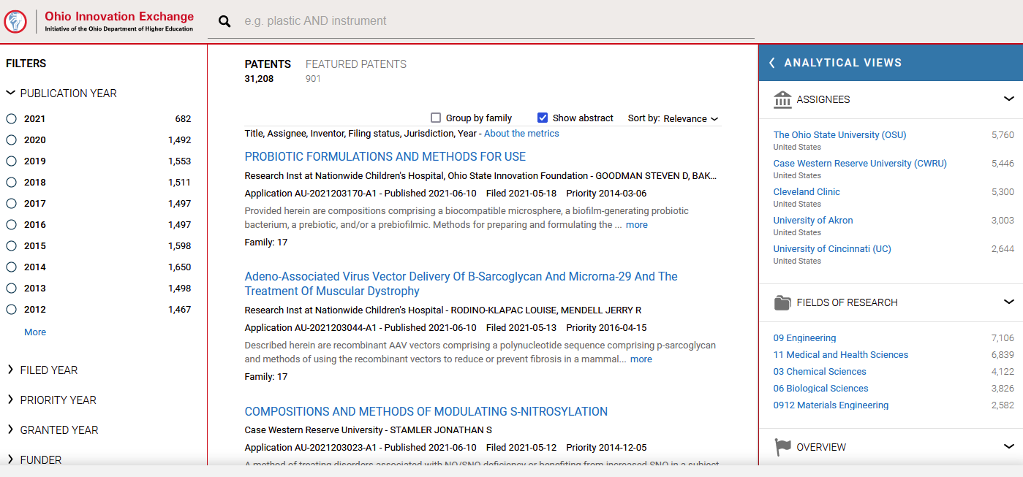
-One can also go directly to “Featured Patents” by clicking this link below the search box.
